Title of Manuscript (Capital Letter of Each Word; Font type: Calibri (body), Font size: 18, Align Centre)

Full Author Name ^{1,2}, Full Name Corresponding Author¹*, Full Author Name¹ (All authors name must be written in full name. Font type Calibri Font Size 10: Paragraph: align centre)

¹Faculty of Business, Multimedia University, 75450 Melaka, Malaysia
²Graduate School of Business, Universiti Sains Malaysia, 11800 USM, Penang, Malaysia
(Please provides full institution/organization address. Font type Calibri Font Size 9: Paragraph: align centre)

* Corresponding Author

Abstract

The abstract should contain between 250 and 300 words. A concise and factual abstract is required. The abstract should state briefly the purpose of the research, the principal results and major conclusions.

Keywords: At least FIVE keywords; Use semicolon as separator

- Introduction (Times New Roman 12 pt, Bold)
The first sentence should start here. [Format for first heading: Use a numbering system starting with 1; All uppercase; Times New Roman, 12 pt, bold, align left; single line spacing].

Second paragraph starts here (single line spacing between paragraph). [Format for body text: No indentation; Times New Roman, 12 pt, justified alignment; 0 pt before and 0 pt after paragraph spacing; single line spacing].

In the manuscript, the author must make sure to have the followings: 1. Introduction 2. Literature Review, 3. Methodology or Materials and Methods, 4. Results and Discussion; 5. Conclusion; Acknowledgement, References. You may add more if required.

The manuscript should be typed with single spacing and should be between 10-15 pages.

2. Literature Review (Times New Roman 12 pt, Bold)
Before introducing any subheadings, it is imperative to write at least one paragraph under the initial heading. Authors have the flexibility to incorporate as many subheadings as necessary, but it is essential to number them appropriately.

2.1 Subheading Title (Times New Roman 12 pt, Bold, Italic)
The first sentence should start here. [Format for first heading: Use a numbering system starting with 1; All uppercase; Times New Roman, 12 pt, bold, align left; single line spacing].

Second paragraph starts here (single line spacing between paragraph). [Format for body text: No indentation; Times New Roman, 12 pt, justified alignment; 0 pt before and 0 pt after paragraph spacing; single line spacing].

2.1.1 Subheading Title (Times New Roman 12 pt, Bold, Italic)
The first sentence should start here. [Format for first heading: Use a numbering system starting with 1; All uppercase; Times New Roman, 12 pt, bold, align left; single line spacing].

Second paragraph starts here (single line spacing between paragraph). [Format for body text: No indentation; Times New Roman, 12 pt, justified alignment; 0 pt before and 0 pt after paragraph spacing; single line spacing].

3. Methodology
Before introducing any subheadings, it is imperative to write at least one paragraph under the initial heading. Authors have the flexibility to incorporate as many subheadings as necessary, but it is essential to number them appropriately

3.1 Subheading Title (Times New Roman 12 pt, Bold, Italic)
The first sentence should start here. [Format for first heading: Use a numbering system starting with 1; All uppercase; Times New Roman, 12 pt, bold, align left; single line spacing].

Second paragraph starts here (single line spacing between paragraph). [Format for body text: No indentation; Times New Roman, 12 pt, justified alignment; 0 pt before and 0 pt after paragraph spacing; single line spacing].

3.2 Subheading Title (Times New Roman 12 pt, Bold, Italic)
The first sentence should start here. [Format for first heading: Use a numbering system starting with 1; All uppercase; Times New Roman, 12 pt, bold, align left; single line spacing].

Second paragraph starts here (single line spacing between paragraph). [Format for body text: No indentation; Times New Roman, 12 pt, justified alignment; 0 pt before and 0 pt after paragraph spacing; single line spacing].

4. Results and Discussion

All tables and figures within the document must be accompanied by a corresponding caption. Tables should be centered on the page. The caption for a table must be positioned above the table, while the caption for a figure should be placed below it. Figures must adhere to publication-quality standards, providing high-resolution images where content is clear and easily readable. Each figure referenced in the body text should be discussed within the paragraph.

Table 1: Simple Example
Column 1 | Column 2 | Column 3
X¹ | 10 | 24
X² | 28 | 10
X³ | 32 | 61
X⁴ | 8 | 15

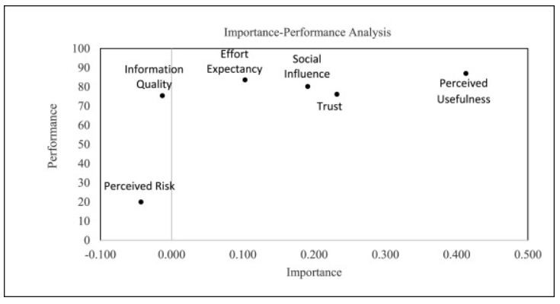
Figure 1: IPMA for repurchase intention

5. Conclusion
Ensure that your paper includes a Conclusion, Implications of the Study, and Recommendations sections as part of its conclusion.

References (Use APA Style)

Alam, M. M. D., and Noor, N. A. M. (2020). The Relationship Between Service Quality, Corporate Image, and Customer Loyalty of Generation Y: An Application of S-O-R Paradigm in the Context of Superstores in Bangladesh. SAGE Open, 10(2), 1-19. doi:10.1177/2158244020924405
Alalwan, A. A. (2018). Investigating the Impact of Social Media Advertising Features on Customer Purchase Intention. International Journal of Information Management, 42(1), 65-77. doi:10.1016/j.ijinfomgt.2018.06.001
Hu, L., Ding, H., Hu, G., Wang, Z., Liu, S., and Liu, Y. (2019). How Perceived Quality of Care Affects Outpatient Satisfaction in China: A Cross-Sectional Study of 136 Tertiary Hospitals. INQUIRY: The Journal of Health Care Organization, Provision, and Financing, 56, 1-8. doi:10.1177/0046958019895397
Omar, C. N. A. (2019, August 23). MyHealth. MyHealth Portal. Retrieved from http://www.myhealth.gov.my/en/dental-charges/
Perera, S., and Waller, D. B. (2020). Case Management Service Quality and Patient-Centered Care. Journal of Health Organization and Management, 34(5), 551-568. doi:10.1108/JHOM-12-2019-0347
The Star. (2019). Malaysia Ranks 1st in World's Best Healthcare Category. Retrieved from https://www.thestar.com.my/news/nation/2019/02/07/malaysia-ranks-1st-in-worlds-best-healthcare-category/

